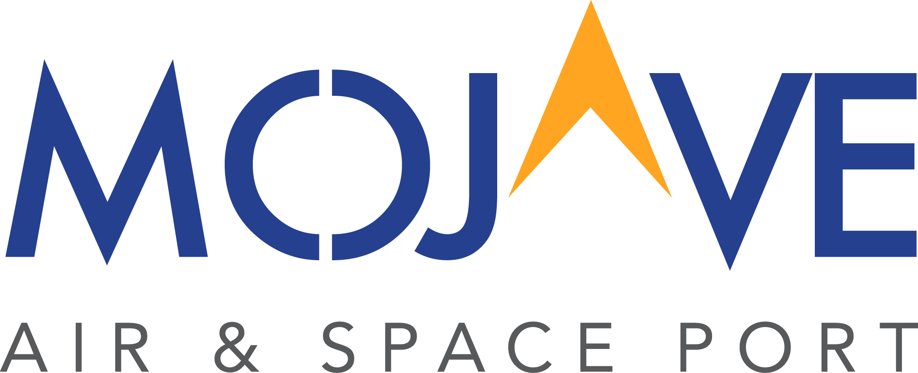
Stuart O. Witt Event Center at Mojave Air & Space Port
Terms and Conditions
Mojave Air & Space Port (MASP), a California Airport District organized and existing under California Public Utilities Code section 22001, et seq., is the owner of certain real property situated in the County of Kern, State of California, also known as Stuart O. Witt Event Center (“Witt Center”).
Licensee is an individual or organization renting the Witt Center for a specific activity described herein.
Features
- 23,408 square feet; 209’ x 112’
- Maximum seated capacity; 1,482
- Heating and cooling
Insurance
- In order to use the facility, Licensee shall take out, at their expense, and keep in force during the event covered by the agreement, general liability insurance, naming MASP as additional insured. A copy of insurance coverage must be submitted to MASP at least thirty (30) days prior to your event date.
Reservations
- In order for an event to be guaranteed, MASP must receive a deposit of at one hundred percent (100%) of the room rental fee. The remaining balance to be paid four (4) weeks before event date.
- Cancelation must be received no less than thirty (30) days in advance to receive a full refund.
- There will be $50 fee for each building key not returned within three (3) business days from the close of event.
Hours of Operation
- 24 hour minimum rental period.
- If not vacated by the delegated deadline there may be a fee of $150.00 per an hour, unless previously approved by MASP staff.
- Licensee is responsible for making sure guests leave the building at an appropriate time in order to allow time for cleanup.
- Arrangements must be made by the Licensee to have rental equipment picked up and removed.
The Witt Center is to be used for
- Civic uses
- Events held by tenants
- Events held by other public agencies
- Other private uses must be approved ahead of time by staff

Facility Usage
- Food preparation area is limited to food preparation only as there is no equipment on the premises for cooking. This means that food may be assembled, warmed, or kept warm using warming ovens, and perishables be refrigerated. Warmers and refrigerators are not supplied. Preparation area must be cleaned to its original state after use.
- Excessive cleanup cost and repair cost will be taken from the deposit.
- Licensee must coordinate any furnishings, catering, audio/visual and additional needs for venue
- MASP can provide recommendations of venders who are familiar with the facility.
- Tables and chairs must have protective rubber feet to prevent scratching the floor.
Security
- MASP requires a security staff for events based on needs. MASP will arrange for security to be paid for by the Licensee.
- Additional security may be required for large events at MASP’s discretion.
Alcoholic Beverage Policy
MASP shall abide by all laws of the State of California concerning the use and serving of alcohol. Each Licensee wishing to have alcohol at their event must abide by the following regulations regarding alcohol use
- Alcoholic beverages may be consumed without a permit when there is no monetary exchange for the beverage and when there is no admission charge for the event.
- In the case of monetary exchange for alcohol, a licensed caterer is required. Please note that the caterer’s insurance only covers the alcoholic beverages, not the Witt Center. Necessary licenses to serve or sell alcohol will be obtained. Any group who sells alcohol, or charges an admission fee and serves alcohol, must obtain a temporary liquor license from the State of California Alcoholic Beverage Control Board. A copy of the license must be on file with MASP, thirty (30) days prior to event.
- A Kern County Deputy is required to be present during the selling and consuming of alcohol for events at the Witt Center.
Responsible Beverage Service Policies and Procedures
- Proof of Age will be required for anyone appearing to be 30 years of age or younger.
- Non-alcoholic beverages (sodas, juices, waters, etc.) will be promoted and made available for the duration of any event where alcohol beverages are sold or served.
- Alcoholic beverage service will be stopped one (1) hour before the conclusion of the event.
- No alcoholic beverages may be brought into or taken out of the event by guest or participants.
- No alcoholic or nonalcoholic beverages will be served in glass bottles, these beverages must be transferred into plastic cups for safety reasons.
Summary of Pertinent California State Laws
- It is illegal to give, serve, or sell alcoholic beverages to any person under age twenty-one (21).
- It is illegal to serve or sell alcoholic beverages to an obviously intoxicated person.
- It is illegal to be intoxicated in public.
- One-day licensed alcohol servers/sellers must be 21 years of age or older.
- It is illegal to drive under the influence of alcoholic or with a blood alcohol level of .08% or higher.
Beverage servers/sellers have the right to refuse service to anyone who appears to be intoxicated or under age 21.
Fire Department and Permits
- Permits may be required for specific activities and Licensee will need to obtain all necessary permits.
- Fire Department services may be required for specific activities, which will incur additional fees.
Clean-Up Responsibilities
- Licensee is expected to provide sufficient supervision to minimize spillage of food and beverages on the facility floors during the rental event.
- Any Licensee leaving excessive trash in the main hall, prep area, restrooms, and/or outside of building is subject to additional charges
- Licensee is responsible for reserving trash dumpsters. Dumpster area is located at the North side of the Witt Center.
- All trash must be placed in dumpsters. If any trash will not fit in the receptacles, such as boxes or large items, these must be broken down and taken out to the trash dumpsters.

